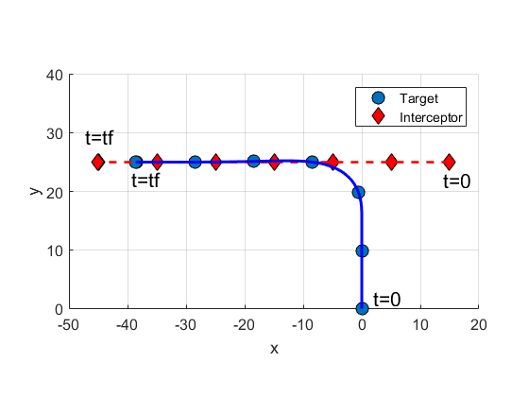

C:\Users\gc117711\Documents\AFRL Research\FollowDistanceRatio\testImage.tif

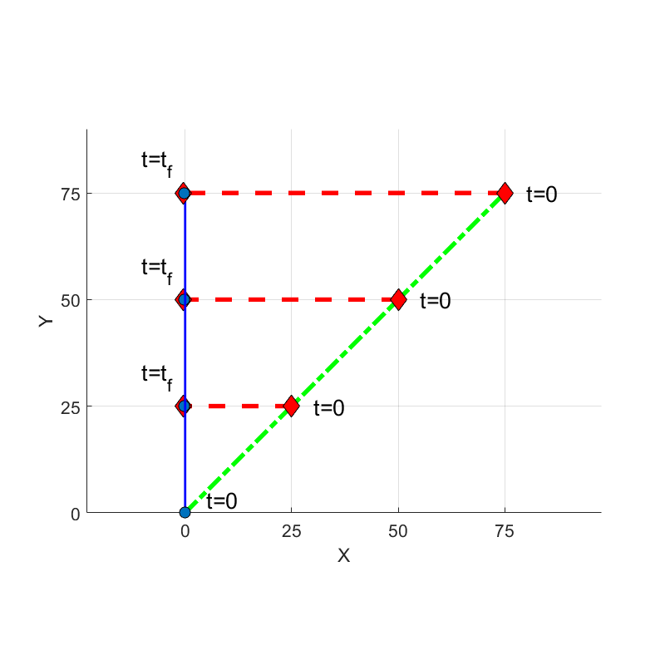

C:\Users\gc117711\Documents\AFRL Research\FollowDistanceRatio\testImage.tif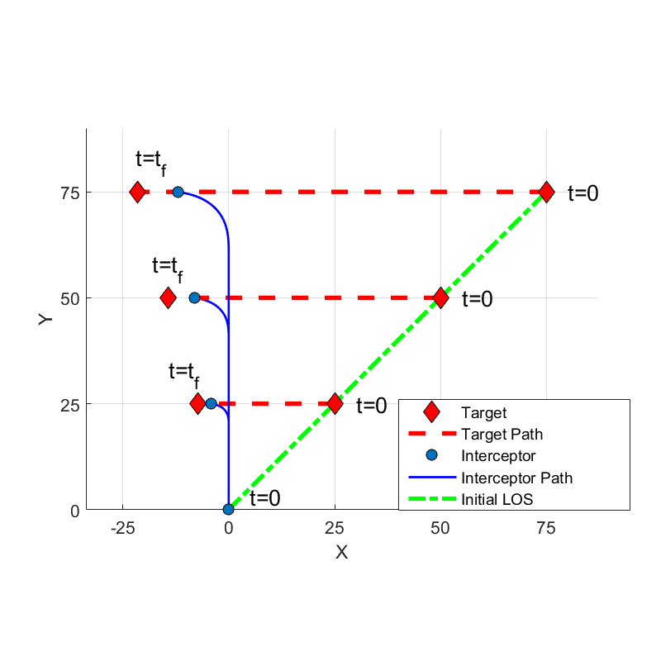

C:\Users\gc117711\Documents\Papers\ICUAS2018\IEEE Format\Updated Figures\targetInterceptorLegend.tif

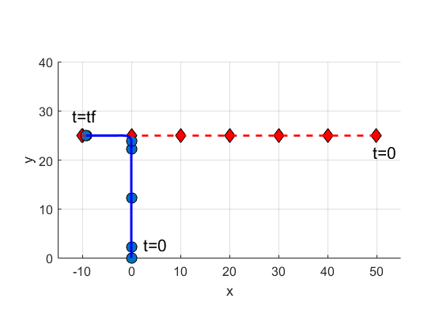

C:\Users\gc117711\Documents\Papers\ICUAS2018\IEEE Format\Updated Figures\targetInterceptorLegend.tif

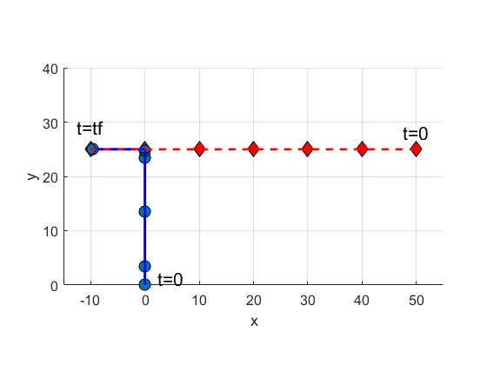

C:\Users\gc117711\Documents\Papers\ICUAS2018\IEEE Format\Updated Figures\targetInterceptorLegend.tif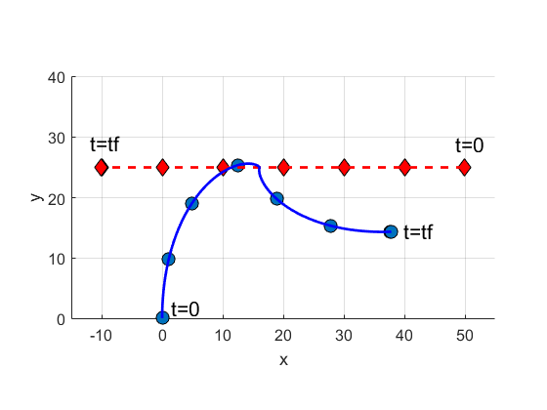

C:\Users\gc117711\Documents\Papers\ICUAS2018\IEEE Format\Updated Figures\targetInterceptorLegend.tif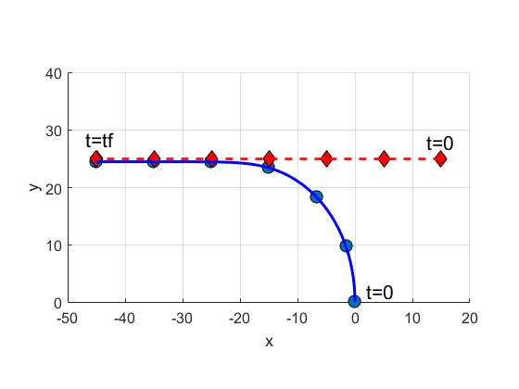

C:\Users\gc117711\Documents\Papers\ICUAS2018\IEEE Format\Updated Figures\legend2.tifC:\Users\gc117711\Documents\Papers\ICUAS2018\IEEE Format\Updated Figures\legend2.tif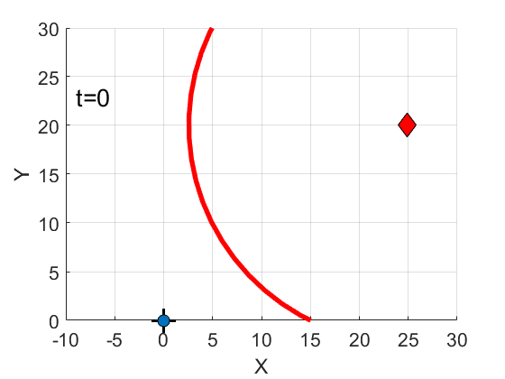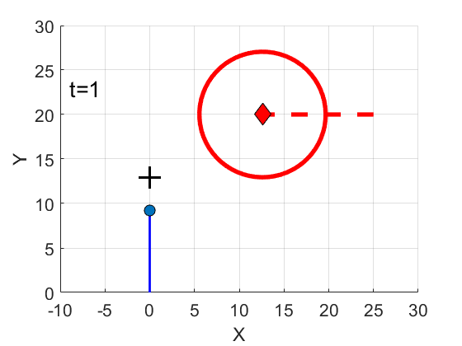

C:\Users\gc117711\Documents\Papers\ICUAS2018\IEEE Format\Updated Figures\legend3.tif

